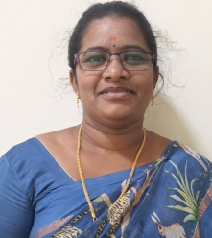
Staff Details (CV to be enclosed)

Name: VATTURI DEVI PRASANNA

Qualification: MCA

Experience: 4 years

Achievements (Individual): UGC NET (Admission to PhD), 17-10-2024, Pursuing PhD.

Any other:
1. Participated in Two-Day international conference on “Transforming Knowledge: A Multidisciplinary Research on Integrative Learning Across Disciplines (MRILAD)” 2025 conducted by The Bhopal School of Social Sciences (BSSS).

2. Participated in a cross continental conference on Intellectual Property Rights (Online Mode) by AVINYA 2.0.

